Table1 Primers used in RT‐PCR analysis
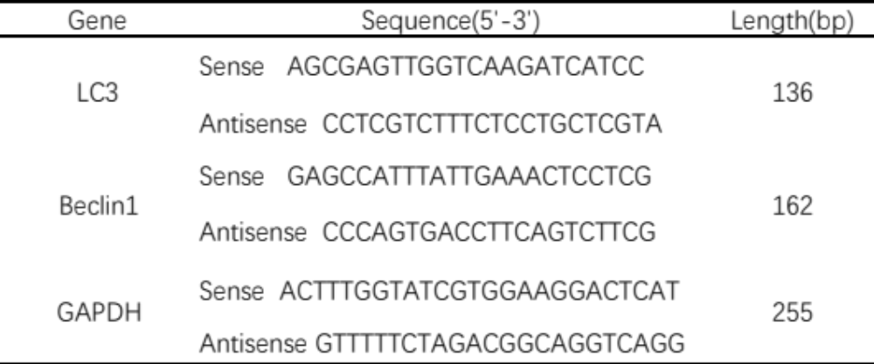
Abbreviation: RT‐PCR, reverse‐transcription polymerase chain reaction.

